CAD[J]

Name: Nafinur Leo

Id: 20-42195-1

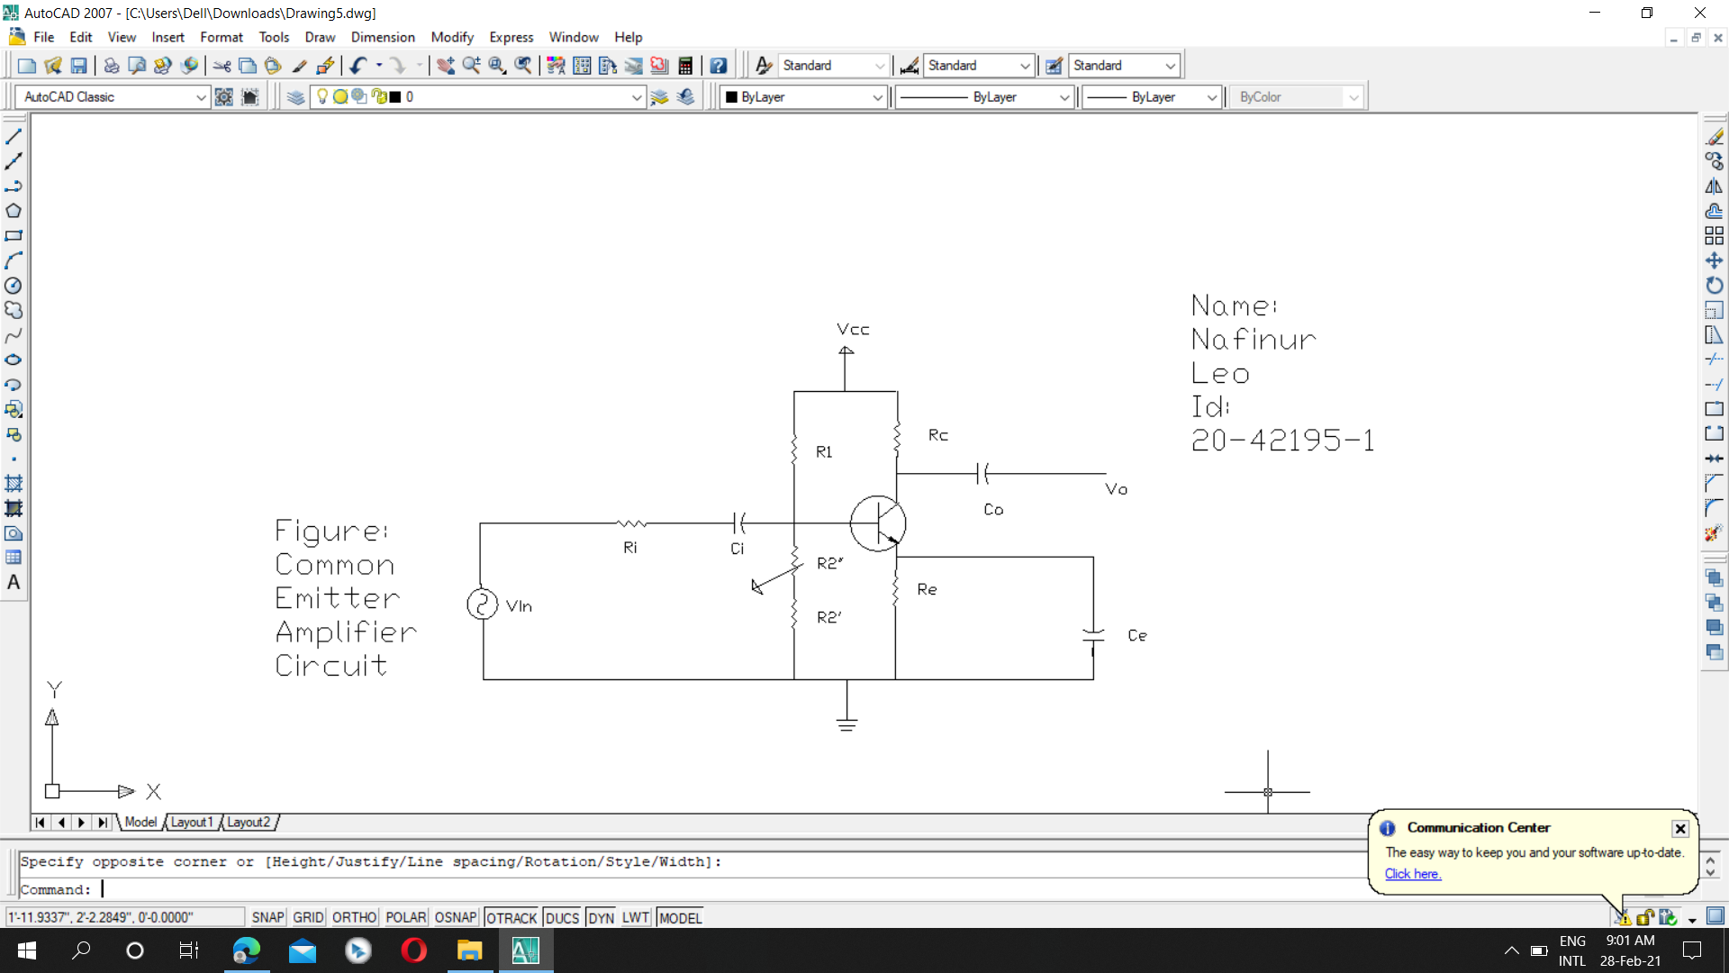

Figure: 01

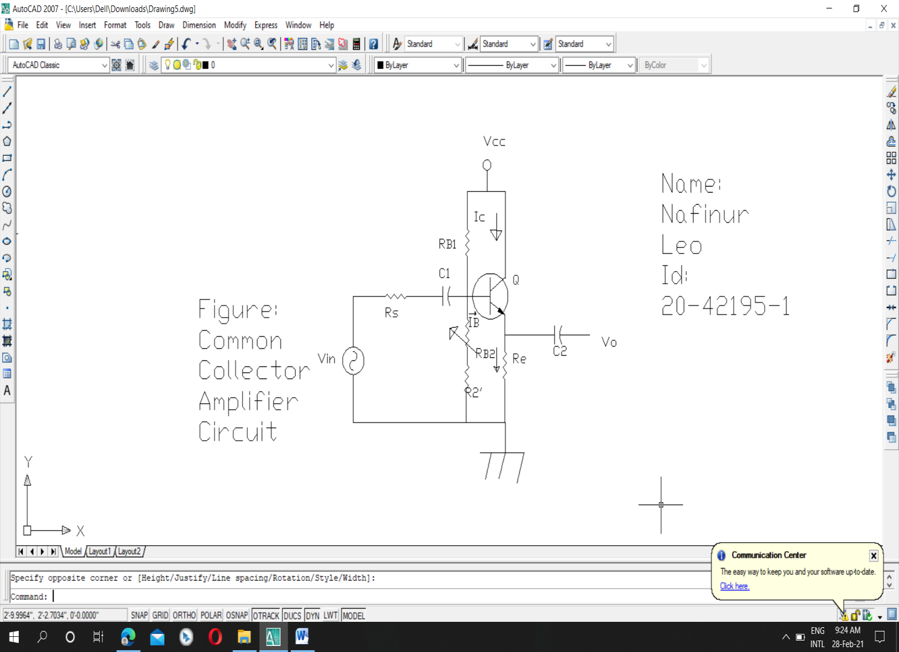

Figure: 02

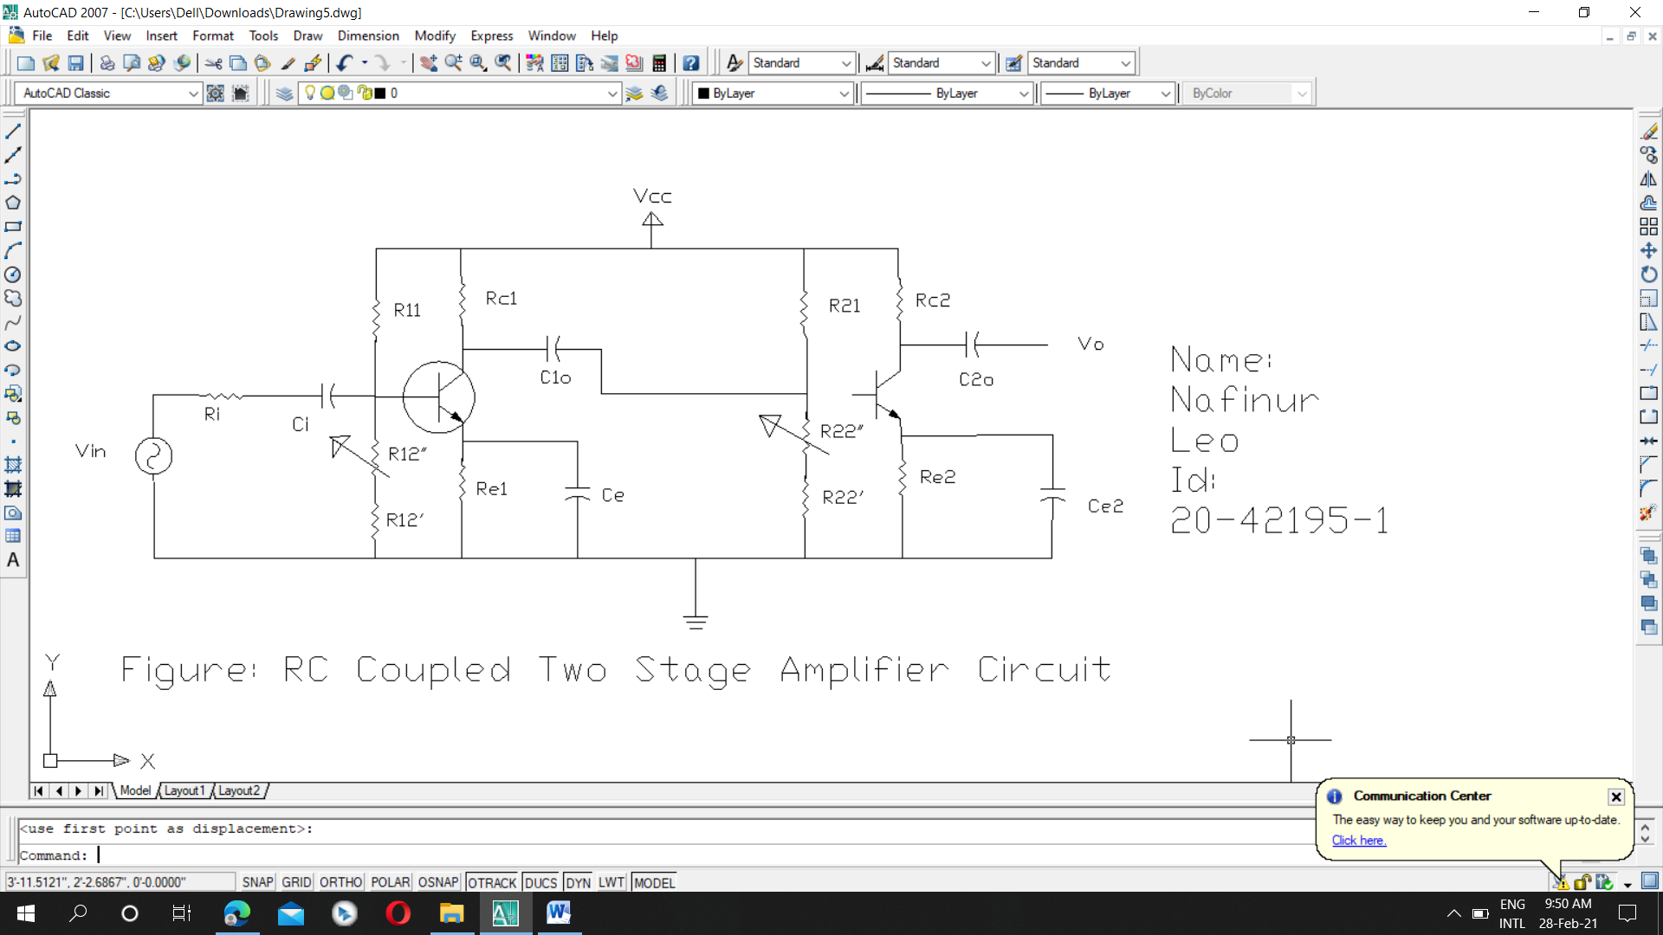

Figure: 03